Ex1:
#define _CRT_SECURE_NO_WARNINGS
#include <stdio.h>
int main() {
int m=29;
printf("Address of m : %x\n",&m);
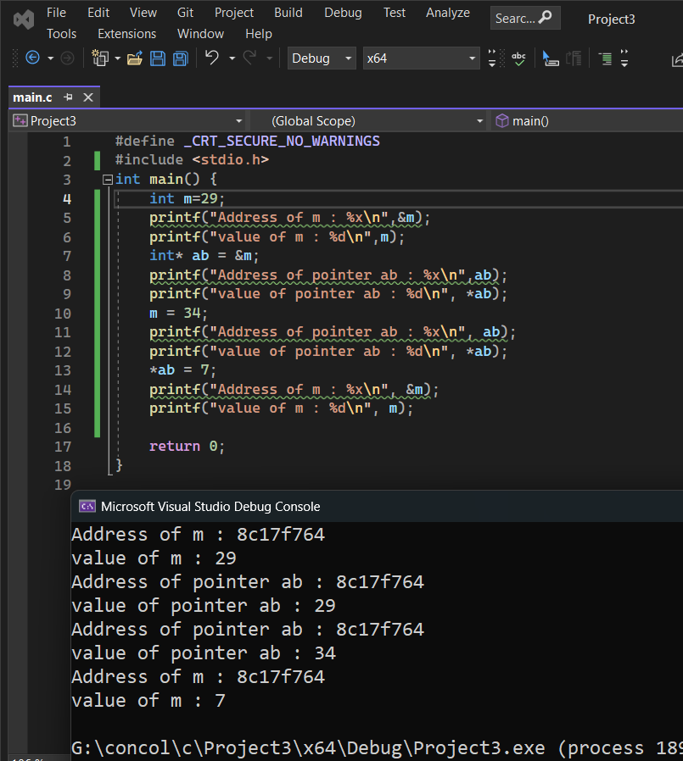
printf("value of m : %d\n",m);
int* ab = &m;
printf("Address of pointer ab : %x\n",ab);
printf("value of pointer ab : %d\n", *ab);
m = 34;
printf("Address of pointer ab : %x\n", ab);
printf("value of pointer ab : %d\n", *ab);
*ab = 7;
printf("Address of m : %x\n", &m);
printf("value of m : %d\n", m);
return 0;
}

Ex2:
#define _CRT_SECURE_NO_WARNINGS
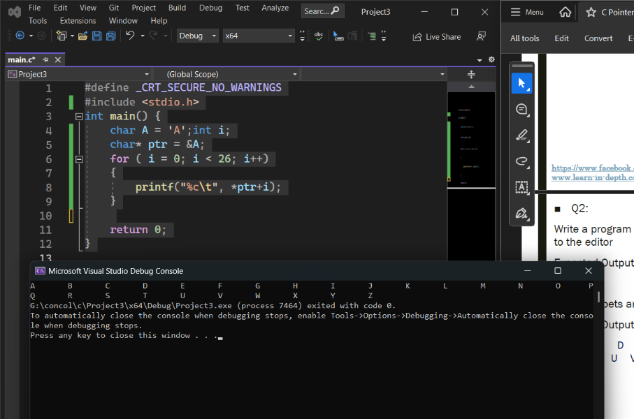
#include <stdio.h>
int main() {
char A = 'A';int i;
char* ptr = &A;
for ( i = 0; i < 26; i++)
{
printf("%c\t", *ptr+i);
}
return 0;
}

Ex3:
#define _CRT_SECURE_NO_WARNINGS
#include <stdio.h>
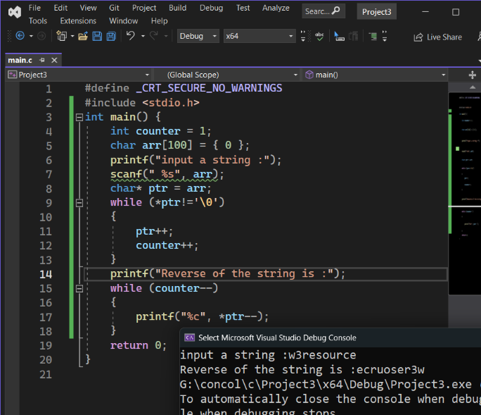
int main() {
int counter = 1; char arr[100] = { 0 };
printf("input a string :"); scanf(" %s", arr);
char* ptr = arr;
while (*ptr!='\0')
{ ptr++; counter++; }
printf("Reverse of the string is :");
while (counter--) printf("%c", *ptr--);
return 0;
}
Ex4:
#define _CRT_SECURE_NO_WARNINGS
#define _CRT_INTERNAL_LOCAL_SCANF_OPTIONS
#include <stdio.h>
int main() {
int arr[15] = { 0 };
printf("Input the number of elements to store in the array(max 15):");
int size;
scanf("%d",&size);
printf("Input %d number of elements in the array:\n",size);
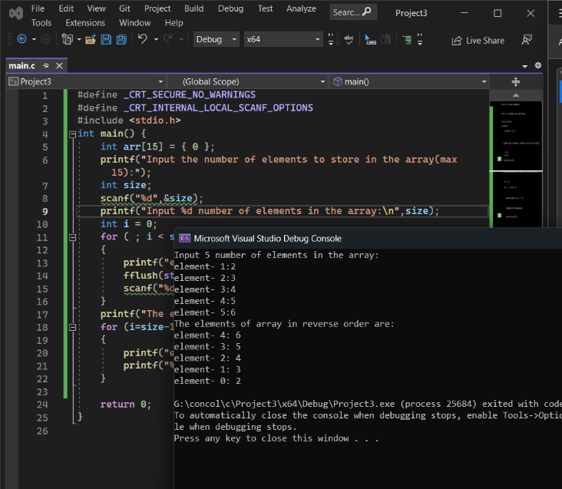
int i = 0;
for ( ; i < size; i++)
{
printf("element- %d:", i + 1);
fflush(stdin);fflush(stdout);
scanf("%d",&arr[i]);
}
printf("The elements of array in reverse order are:\n");
for (i=size-1; i >=0; i--)
{
printf("element- %d: ", i );
printf("%d\n",arr[i]);
}
return 0;
}

Ex5:
#define _CRT_SECURE_NO_WARNINGS
#include <stdio.h>
#include<string.h>
struct Employee
{
char name[15];
int id ; };
int main() {
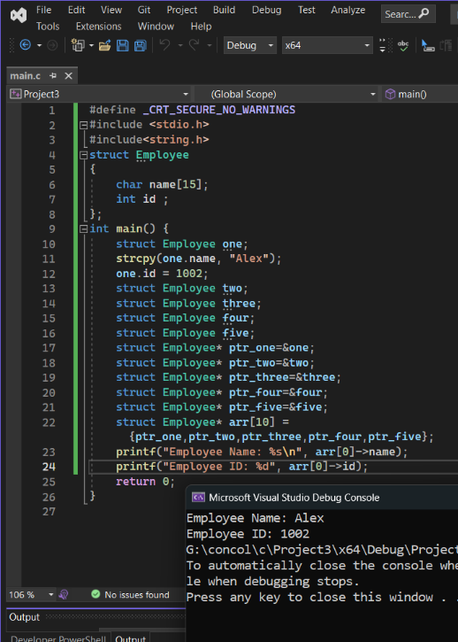
struct Employee one;
strcpy(one.name, "Alex");
one.id = 1002;
struct Employee two;
struct Employee three;
struct Employee four;
struct Employee five;
struct Employee* ptr_one=&one;
struct Employee* ptr_two=&two;
struct Employee* ptr_three=&three;
struct Employee* ptr_four=&four;
struct Employee* ptr_five=&five;
struct Employee* arr[10] = {ptr_one,ptr_two,ptr_three,ptr_four,ptr_five};
printf("Employee Name: %s\n", arr[0]->name);
printf("Employee ID: %d", arr[0]->id);
return 0;
}

